*Is z-test and t-test one and the same ?? or different??*

To come to a conclusion on this, let us see first what they both are and then let’s come to a conclusion.

First, what is a z-test?

A z-test is a statistical test used to determine whether two population means are different when the variances are known and the sample size is large. The test statistic is assumed to have a normal distribution, and the parameters such as standard deviation should be known in order for a accurate z-test to be performed.

A z-test includes a one-sample test, two sample test, a paired difference test. z-test is best used for sample size greater than 30, as the number of samples gets larger, the samples are considered to be approximately normally distributed.

The outcome of z-test produces a z-score, that tells you how far in standard deviations, a data point is from mean of the data set.

________________________________________________________________________________

Now that we know what a z-test is, let’s see what a t-test is...

A t-test is a type of inferential statistic used to determine if there is a significant difference between the means of two groups, which may be related in certain features. A t-test is used as a hypothesis testing tool, which allows testing of an assumption applicable to population.

A t-test looks at the t-statistic, t-distribution values, and the degrees of freedom to determine the statistical significance. To conduct a test with three or more means, one must use an analysis of variance.

Essentially, a t-test allows us to compare the mean valued of two data sets and determine if they came from same population.

Similar like in a z-test, t-test also includes one-sample test, Independent test (two sample test) and Dependent test.

An independent t-test determines whether there is a statistically significant difference b/w means in 2 unrelated groups.

Whereas, a Dependent t-test is an example of “within subjects” or repeated measures. The related groups indicates that the same participants are tested more than once and thus, the “related groups” indicates that same participants are present in both groups. To calculate a t-test , 3 values are required that includes Mean difference from each data set, the standard deviation of each group and number of data values of each group.

The outcome of t-test produces a t-value. This value is compared against a value obtained from critical value table (T-Distribution Table). The lager the t-score indicates the groups are different and a smaller score indicated the groups are similar.

Conclusion:

Both, z-tests and t-tests require data with a normal distribution, which means the sample (or population) data is distributed evenly around the mean. A z-test is usually preferred when the sample size is very large (usually >30). In case where the sample size is less than 30(<30), a t-test is carried out. When the standard deviation of population is known, a z-test is carried , else a t-test is performed.

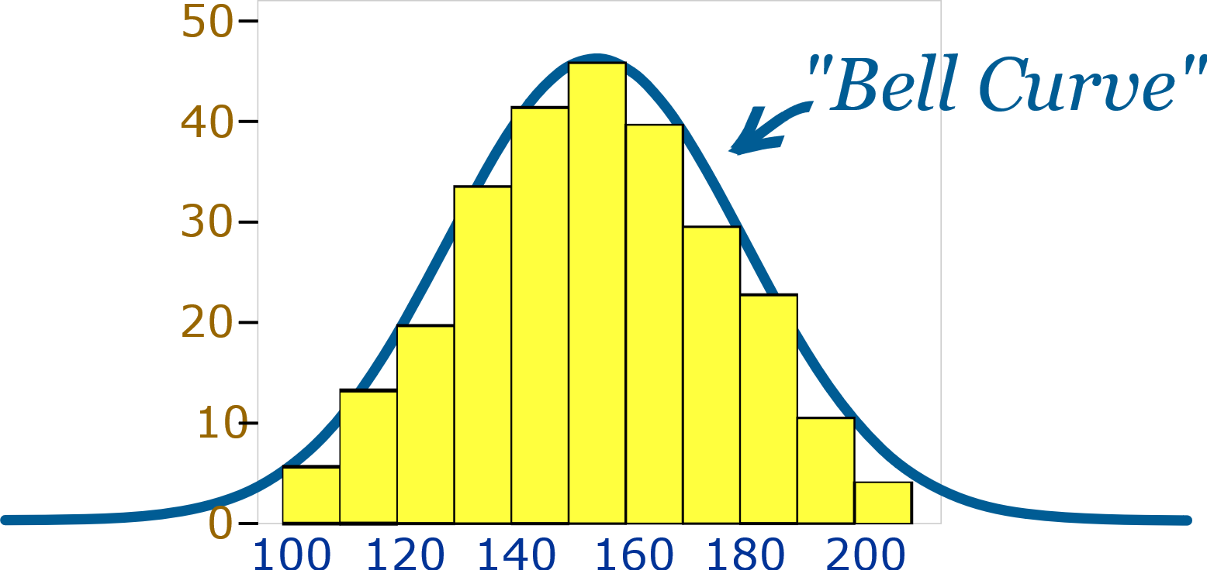

|  |  |  |
| --- | --- | --- |
| Parameters | Z-test | T-test |
| Distribution of the data | *Normal Distribution* | *Normal Distribution* |
| Sample size | *>30* | *<30* |
| Standard Deviation known | *Of population* | *Of sample* |